
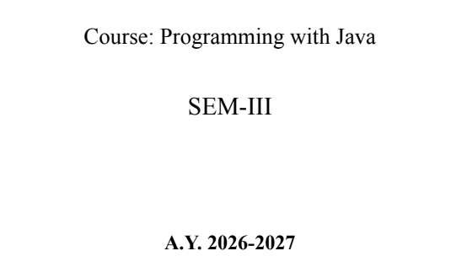
NAME: BHOOMI VIJAYVARGIYA
BATCH: A2
PRN: 25070122062

ASSIGNMENT No : 8
TITLE : Write a Java program to demonstrate the use of the super keyword in inheritance.
Problem Statement: Write a Java program to demonstrate the use of the super keyword in inheritance.
Learning Objectives:
To demonstrate the use of the super keyword for accessing parent class members.
Theory:
The super keyword is used to refer to the immediate parent class in Java. It can invoke parent class constructors, access parent class variables, and call overridden methods. Super helps distinguish between parent and child class members with the same name. It ensures proper constructor chaining during object creation. It is an important concept in inheritance and method overriding.
Code:
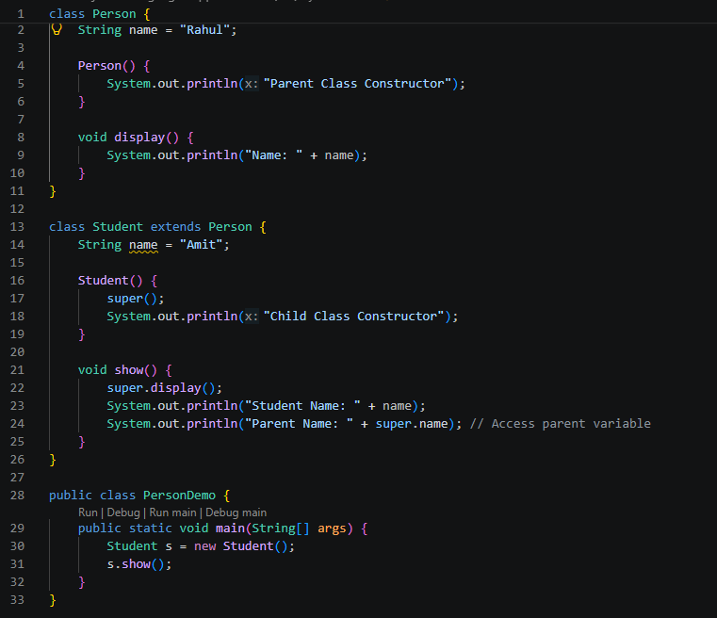
Outcome
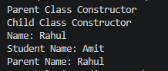
Conclusion
This experiment demonstrates the use of the super keyword in Java inheritance to access the parent class constructor, methods, and variables from a child class. It helps in reusing existing code, avoids duplication, and resolves ambiguity when parent and child classes have members with the same name. Overall, the super keyword improves code organization, maintainability, and the effective implementation of object-oriented programming principles.

Exercise
1.Create an Employee and Manager program where Manager accesses Employee details using super keyword.
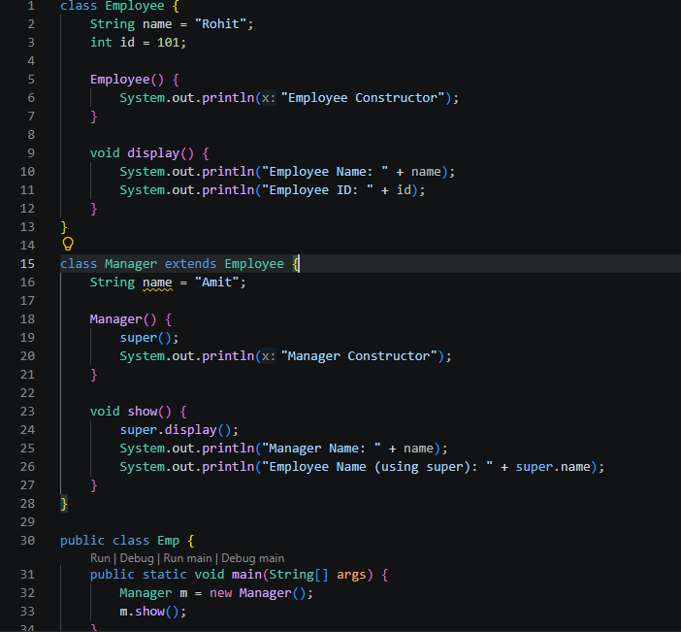

2. Develop a Vehicle Insurance System where child insurance classes access parent vehicle information using the super keyword.
